CH’s amburr Tools

Manual for version 1.0

CH’s amburr Tools is an all-in-one tool that you will definitely fall in love with! There are many interesting functions such as spamming, removing messages, editing images and texts, reading PDF documents, playing games, and many more!  
  
This manual will guide you through the various lovely functions. If you enjoy it, don’t forget to support us by sharing with your friends! <3

# Login

This is a process to personalise your tool!

Simply enter your name in the first textbox, then press login.

Your name will now be displayed on the home page!

# Spammer

This spammer will help you spam in almost every application. Not only can you use this to surprise your friends, you can also farm XP and credits in many games.

Step 1: Open Tools -> Spammer.

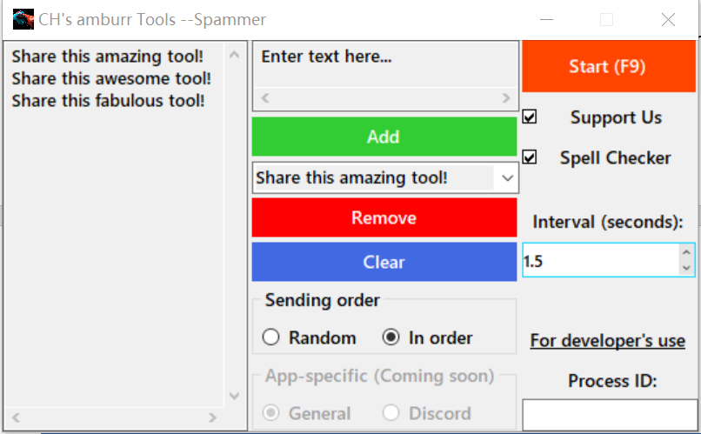Step 2: Enter your text in the textbox and click ‘Add’.

Step 3: Enter an interval.

Step 4: Choose the order to send the texts.

Step 5: Click ‘Start’, or the hot key F9.

Step 6: Highlight your cursor in the textbox. Your spam will be directed there.

Other features:

* To remove a line, select it in the drop-down box and click ‘Remove’.
* To clear all the contents, click ‘Clear’.
* To add an advertisement and show support, check ‘Support Us’.
* The spell checker will help to check your spelling. This is provided by Progress Telerik. More information can be found here: <https://www.telerik.com/products/winforms/spellchecker.aspx>

# Message Remover

This tool can help to remove your own messages in a certain channel in Discord.

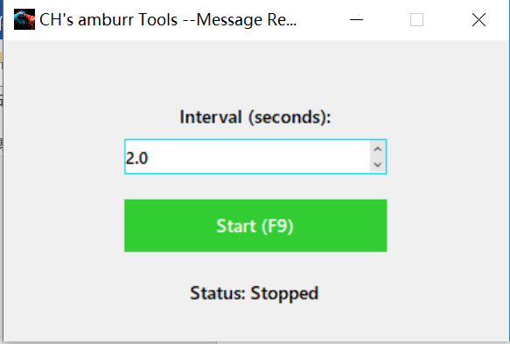Step 1: Open Tools -> Message Remover.

Step 2: Enter an interval.

Step 3: Click start, or the hot key F9.

Step 4: Highlight your cursor in the textbox.

Step 5: Wait a few seconds as the removal begins.

# Image, text editor, and PDF viewer

These tools are lightweight yet useful. They may not be as good as Adobe Photoshop, Microsoft Word, or Adobe Acrobat DC, but can certainly come in handy with their easy-to-use functions. These are provided by Progress Telerik. More information can be found in the following websites.

<https://www.telerik.com/products/winforms/image-editor.aspx>

<https://www.telerik.com/products/winforms/richtexteditor.aspx>

<https://www.telerik.com/products/winforms/pdf-viewer.aspx>

# Pokémon Finder

This simple tool will help you cheat in Pokécord.

Step 1: Select the folder “Assets” which came with the application. It is under the application start-up folder (Default: C:\Program Files(x86)\CH’s amburr\Assets).

Step 2: Drag the spawn image into any local folder (e.g. Desktop).

Step 3: Drag the image from your local folder to the image box (or double click the box).

Step 4: (Optional) Change the options.

Step 5: Click “Search”.

Step 6: Hover over the same picture and the name will appear.

Sorry that I could not program it for the image to be automatically downloaded in RAM. As the local folder cannot store two files with the same name, you will need 2 folders to store them. You can also correct the Pokémon search result, or add additional Pokémons into the “Assets” folder in the application start-up folder.

Conway’s Game of Life

Thanks to .ı.l.ı. CLU7CH3R .ı.l.ı.#8220, this simple game can entertain you when you are bored. Try out a variety of patterns and watch the outcome.

The universe of the Game of Life is an infinite, two-dimensional orthogonal grid of square cells, each of which is in one of two possible states, alive or dead, (or populated and unpopulated, respectively). Every cell interacts with its eight neighbours, which are the cells that are horizontally, vertically, or diagonally adjacent. At each step in time, the following transitions occur:

1. Any live cell with fewer than two live neighbours dies, as if by under population.
2. Any live cell with two or three live neighbours lives on to the next generation.
3. Any live cell with more than three live neighbours dies, as if by overpopulation.
4. Any dead cell with exactly three live neighbours becomes a live cell, as if by reproduction.

The initial pattern constitutes the seed of the system. The first generation is created by applying the above rules simultaneously to every cell in the seed; births and deaths occur simultaneously, and the discrete moment at which this happens is sometimes called a tick. Each generation is a pure function of the preceding one. The rules continue to be applied repeatedly to create further generations. (Source: Wikipedia)

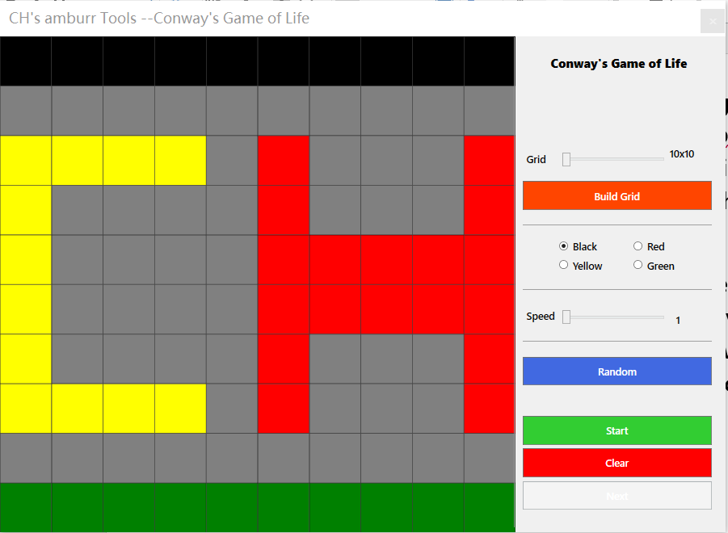To start playing:

Step 1: Adjust the slider and click ‘Build Grid’

Step 2: Choose a colour that you like.

Step 3: Adjust the speed.

Step 4: Click on the cells to toggle them, or you can click the ‘Random’ button as well.

Step 5: Click ‘Start’.

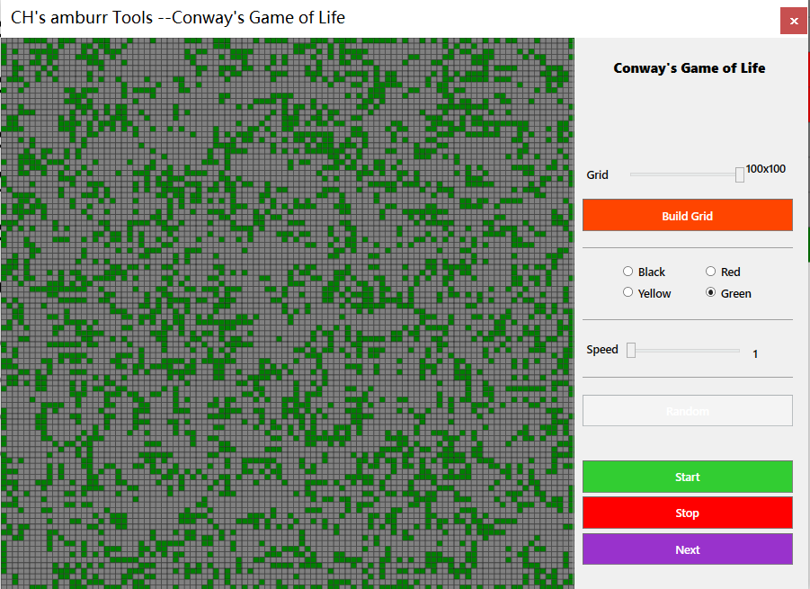Other features:

* Click ‘Clear’ to reset the grid.
* Click ‘Pause’ to pause.
* Click ‘Stop’ to end the game.
* Click ‘Next’ to go to the next step. (This only works after a pause )

# Themes

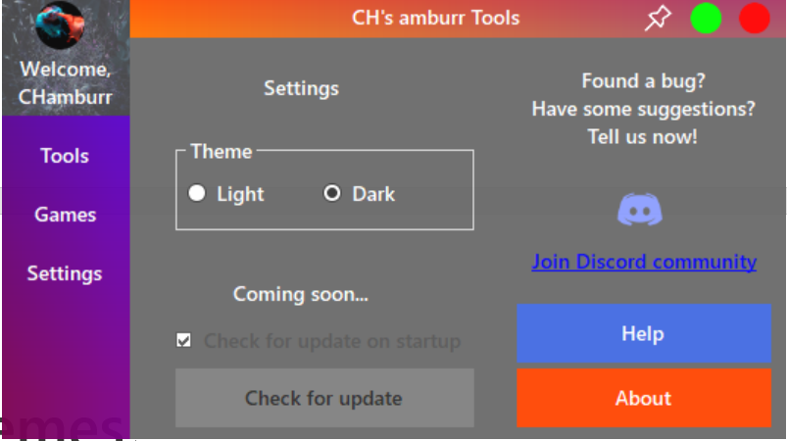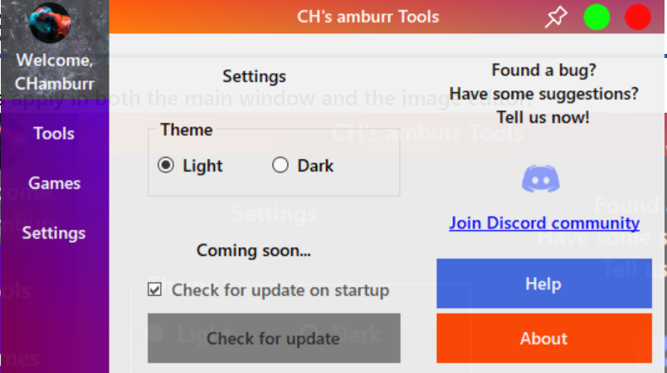Themes apply in both the main window and the image editor, and can be changed from the settings.

# Always-on-top

This function will let all open CH’s amburr Tools window stay on top of the others. It can be handy when using the spammer and message remover. The pin in the main window will trigger this function.

# About box

This can be triggered from Settings -> About. It shows basic information of the application including title, version, icon, changelog etc.

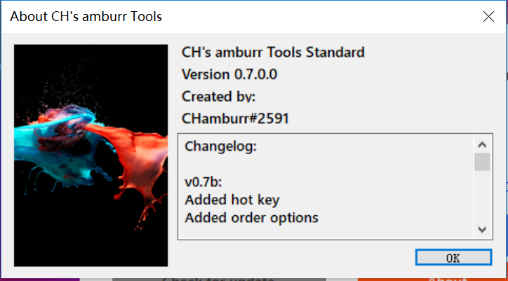

文本段落旁边。尝试探索文字环绕：选择此处的图片，转到“**格式**”>“**环绕文字**”，然后使用上箭头/下箭头键在选项之间切换以预览效果。

# Feedback

Your feedback is precious to us. You can join our official Discord server and give us suggestions, report bugs, ask questions, and more. If you enjoyed using the tool, don’t forget to share it with your friends.

<https://discord.gg/TYe3U4w>

# Disclaimer

This program is discontinued due to an increased number of misuse. To learn more, message CHamburr#2591.